

**Gloo!**

*Making student-teacher*

*connections that stick!*

Final Report

CS147 Autumn 2024

Justin Blumencranz | Monica Hicks | Matthew Mattei | Alison Rogers

## Table of Contents

**Table of Contents 2**

Project Name and Value Proposition 3

Team Member Names and Roles 3

Problem + Solution Overview 4

Needfinding 5

Interviews 5

Synthesis 6

Learnings 7

POVs, HMWs, Solutions, & Experience Prototypes 8

POVs and HMWs 8

Solutions 10

Experience Prototypes 11

Design Evolution 15

Final Solution 15

Description 15

Rationale 15

Tasks 16

Make a Profile (Simple Task for Teachers and Students) 16

Find a Connection (Moderate Task for Students) 17

Create and Share Office Hours (Complex Task for Teachers) 18

Record Meeting Notes (Moderate Task for Teachers and Students) 18

Design Evolution 20

Alternate Realizations 20

Lo-Fi Sketches 21

Lo-Fi Prototype Testing 22

Med-Fi Prototype 23

Results of Heuristic Evaluation 24

Values in Design 29

Core Design Values 29

Final prototype implementation 31

Tools used 31

Hard-coded Techniques 31

Wizard of Oz Techniques 32

Reflection and Next Steps 32

Main Takeaways 32

Next Steps 32

Appendix 33

### Project Name and Value Proposition

**Project Name**: Gloo

**Value Proposition**: Making student-teacher connections that stick!

### Team Member Names and Roles



Justin Blumencranz

User Researcher | Mobile/Web Developer

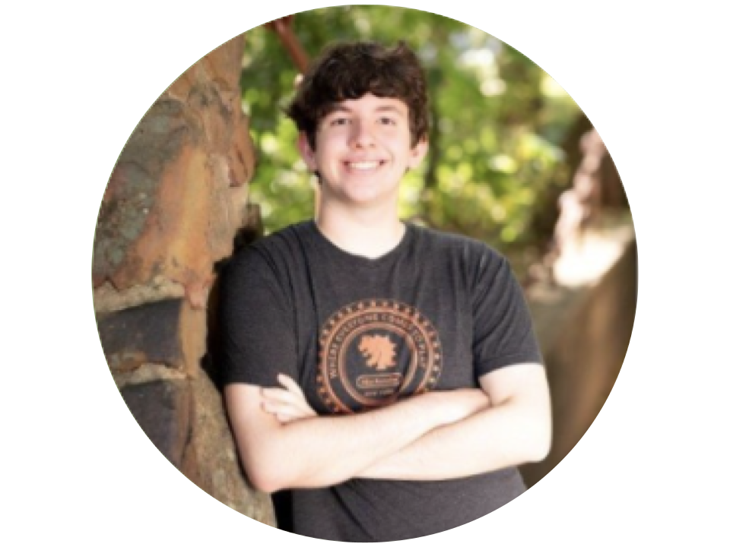

Matthew Mattei

User Researcher | Mobile Designer/Dev



Monica Hicks

User Researcher | Mobile Developer



Alison Rogers

User Researcher | Mobile Developer

### Problem + Solution Overview

**Problem**

Especially in larger schools, students feel daunted by and disconnected from the college application process. At the same time, teachers have a hard time connecting with students and being able to advocate for them.

**Solution**

Gloo provides interest-based, AI-generated teacher mentor recommendations to students, allows teachers to share meeting availability, and offers journaling to help users remember and reflect on interactions.

### 

### Needfinding

#### Interviews

To get a fuller idea of the existing landscape, we prioritized a diverse range of participants for our needfinding interviews. We used cold-approaching in shopping centers to obtain in-person interviews with several local high school students, and we made use of our personal networks – through texting, posting on Facebook, showing up to their office – to obtain interviews with college admissions counselors and a home-schooled student. We compensated our interviewees with rewards such as lunch, gift cards, and cash.

For our first round of interviews, we focused on uncovering pain points of the student experience. We interviewed Sasha (Menlo-Atherton High School), Jerry (Palo Alto High School), Anwar (Homeschooled), and June (Menlo High School). Note that we are referring to interviewees by pseudonyms to protect their identity. With the exception of our extreme user interview conducted over Zoom, all interviews were conducted in person. For each of the four interviews we had a dedicated notetaker, allowing the rest of us to watch for facial expressions, body language, and non-verbal cues. Drawing from the master/apprentice method for needfinding interviews, we thanked them for their willingness to talk to us, emphasizing that our time away from high school made their expertise invaluable in helping us understand the current student experience.

We used the findings from our first interviews to shape the content of our round-two interviews. For our second-round interviews, we interviewed Ryder, another local high school student, Erica, a high school admissions counselor, and Sue, an education admissions consultant and parent.

#### Synthesis

After talking to our interviewees, we made empathy maps to reflect on each individual. We looked at the common topics between what the interviewees said and did and what we believed that said about how they thought or felt.

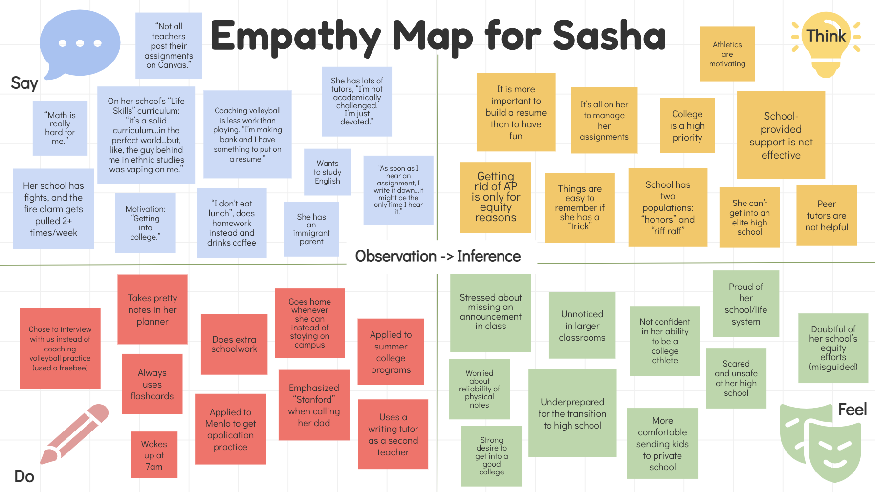 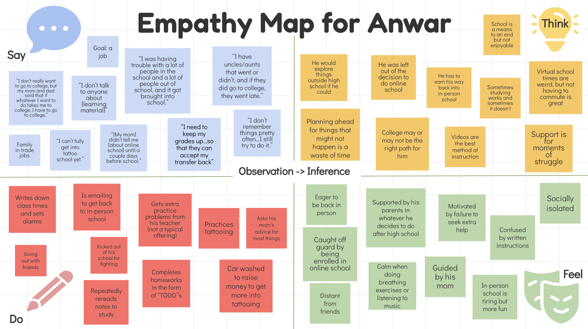

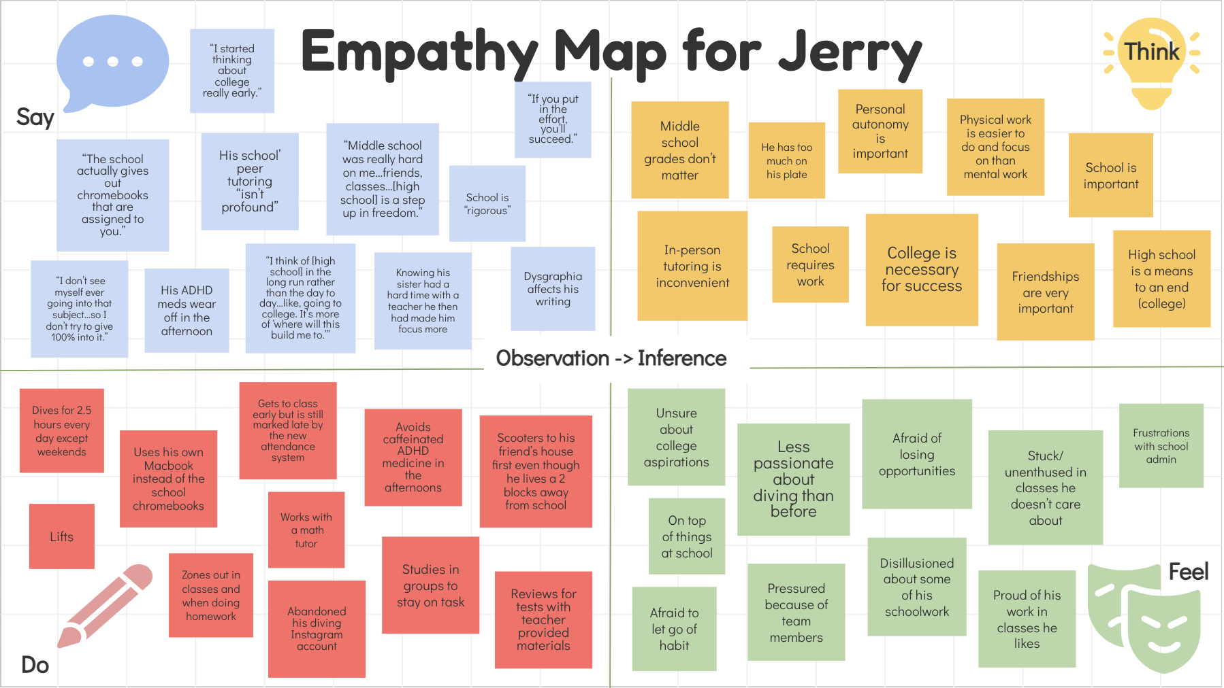 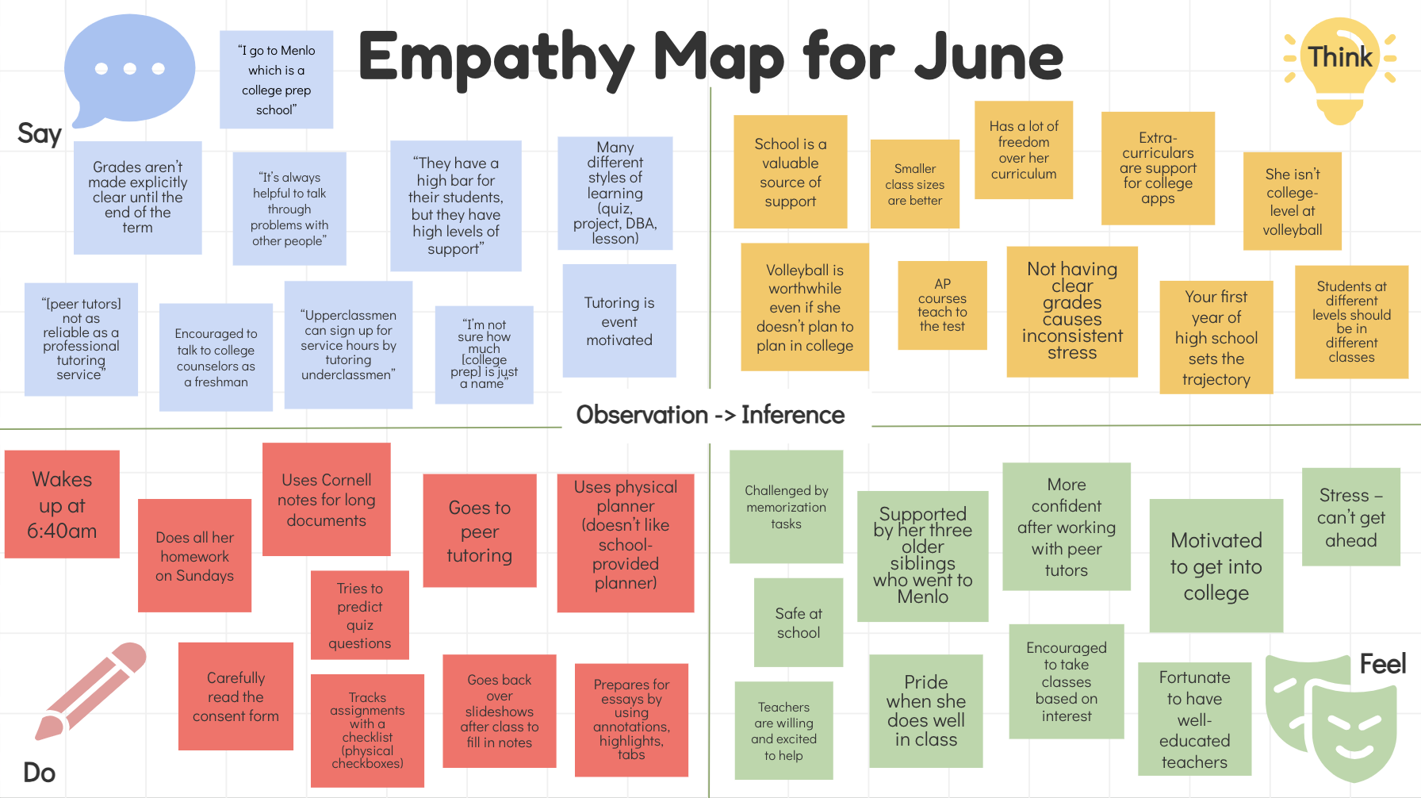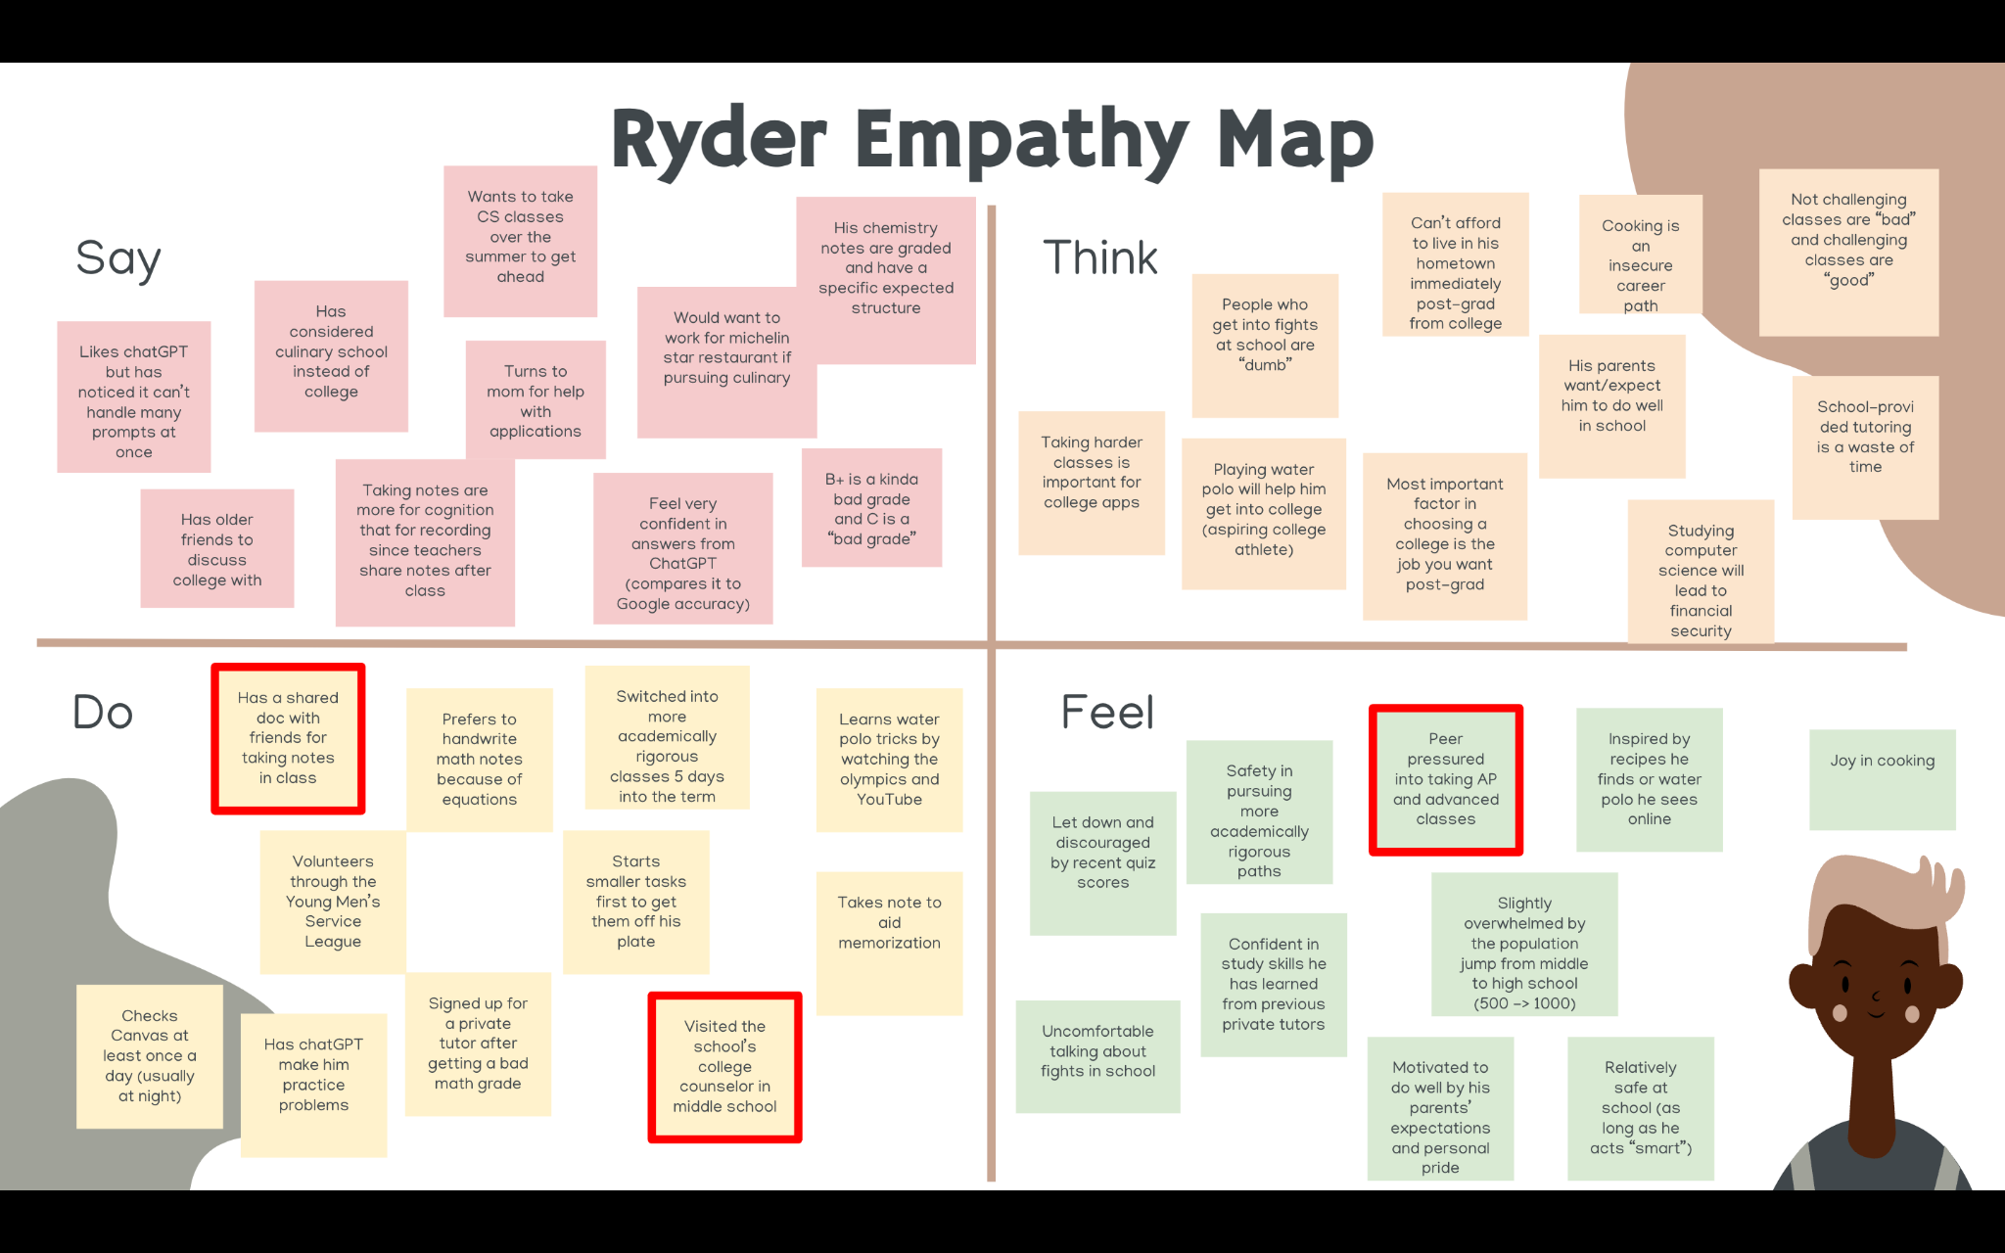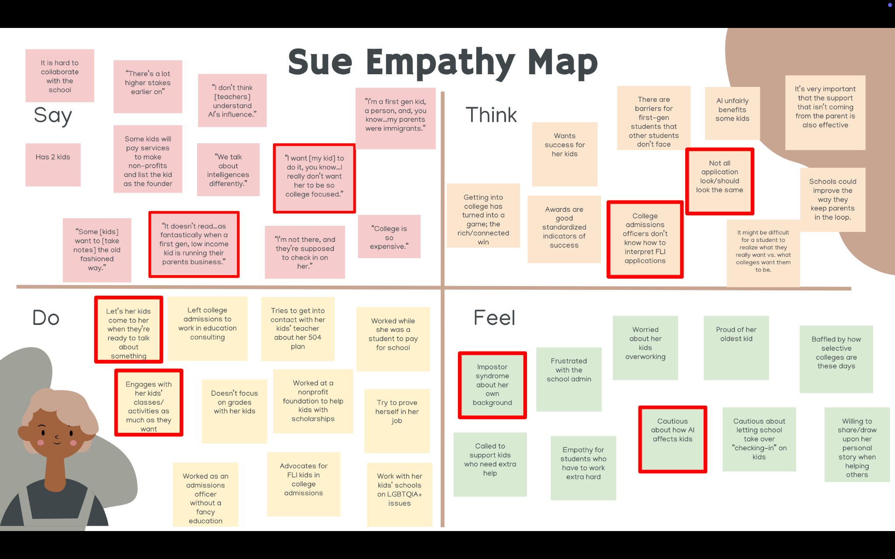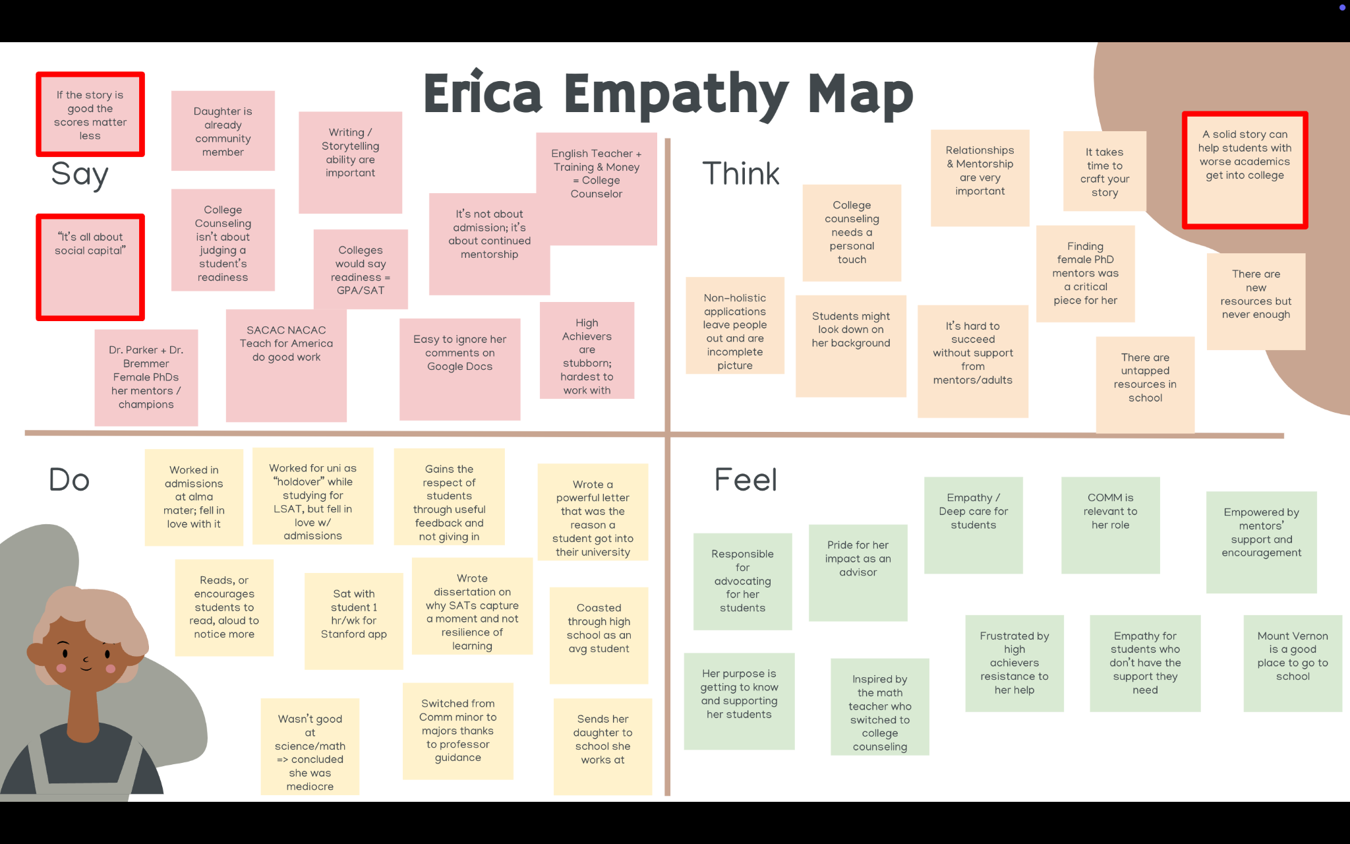

#### Learnings

In our first round of interviews, we found that students were looking for reliable and trustworthy support (Sasha and Jerry), familiar and predictable spaces to learn in (Anwar and Sasha), and ways to explore what their life will look like post-high school (Jerry and June).

We narrowed our problem domain from the broad topic of high school students to looking at what connection looks like for high school students. We tailored our second-round interviews to go deeper on these topics by refining our questions and pursuing interviews with members in this problem space.

In these interviews, we found that adults felt concerned about the disconnect between students and their teachers and that this disconnect can be especially damaging for FLI students. Especially when it comes to college recommendation letters and admissions decisions, our users emphasized how influential strong advocacy can be on the future of a student (Erica and Sue). Additionally, the stakes for students also seem incredibly high from a very early age, leading to very high pressure (Sue, Erica, and Ryder). We also noticed that students tend to reach out to each other for peer academic support, such as with group notes, even though they tend not to trust other peer-focused resources, such as peer tutoring (Ryder).

Our core takeaways after both sets of interviews centered around the high pressures that students face at an increasingly early age, the ways students team up to tackle academic tasks together, and the impacts that support from adults in education can have on students.

### 

### POVs, HMWs, Solutions, & Experience Prototypes

#### POVs and HMWs

We took our three most insightful interviews and used them to generate POV statements. From there, we synthesized the data to generate How Might We… statements for each of the three participants we spoke with.

**Sasha**

**We met** Sasha, a high schooler coaching volleyball obsessed with academic success.

**We were surprised to notice** she no longer plays volleyball, despite enjoying it, in favor of a coaching job that looks better on her college application.

**We wonder if this means** she believes sacrificing her high school enjoyment is necessary to secure a future.

**It would be game-changing to** convince Sasha that she can pursue her genuine passions *and* set herself up for success.

Here are a few of the 12 HMWs we generated from Sasha’s POV:

**How might we…**

* Make curating a college app like therapy?
* Make curating a college app like a bucket list?
* Transform her “wastes of time” into key elements of her story?
* Provide more clarity/guidance around what admissions is looking for in a “holistic” application.
* Remove the pressure to “spend 100% of your time” on getting into college.

**Ryder**

**We met** Ryder, a high school student who combines digital group notes with friends to guarantee note quality.

**We were surprised to notice** he doesn’t combine notes with other students in his hardest subject, math, where he prefers to write his notes on paper.

**We wonder if this means** he distrusts the quality and accessibility of other students’ notes when they aren’t made collaboratively.

**It would be game-changing to** enable Ryder to feel confident in his peers’ notes, even when made independently, lessening his personal note-taking burden.

Here are a few of the 12 HMWs we generated from Ryder’s POV:

**How might we…**

* Make combining handwritten notes cleaner and faster?
* Make taking quality notes more enjoyable?
* Involve the teacher in the notetaking process?
* Make notetaking a contest or competition?

**Anwar**

**We met** Anwar, a Bay Area student trying to transfer out of a virtual high school that only cares about attendance.

**We were surprised to notice** his classes are so poorly timed that he has to handwrite his schedule and set numerous alarms to make his classes.

**We wonder if this means** he feels unsupported by his school’s admin and solely responsible for his transfer’s success.

**It would be game-changing to** reduce his organizational burden to give him the confidence to focus his energy on schoolwork.

Here are a few of the 11 HMWs we generated from Anwar’s POV:

**How might we…**

* Make getting to class an effortless routine?
* Help him build upon his existing time management skills to make school less stressful?
* Create an incentive or gamify arriving on time?
* Make scheduling and time management the most exciting part of his day?

#### Solutions

After digging deeper into the needs of our interviewees, we brainstormed solutions, each of us coming up with 3-5 solutions for each of our top HMW statements. We conducted several rounds of voting with diminishing votes to narrow it down to our top 3 solutions.

**Top Solution #1 (inspired by Sasha):** Make a list of broad interests/areas of interest that generates actionable ideas/hobbies that could be relevant to college apps and acts like a bucket list of things to do.

**Top Solution #2 (inspired by Sasha):** A platform for fostering deeper connections with your teachers so they can understand who you are and support you with more personalized recommendations, advocacy, and interactions.

**Top Solution #3 (inspired by Ryder):** AI that goes through different students’ handwritten notes and highlights the major factual differences between them.

#### Experience Prototypes

To motivate an evidence-based final solution, we brainstormed assumptions critical to our working solutions’ success. We took those assumptions and conducted experience prototypes in order to evaluate those assumptions.

**Experience Prototype #1**

Make a list of broad interests/areas of interest that generates actionable ideas/hobbies that could be relevant to college apps and acts like a bucket list of things to do.

**Assumption:** Bucket lists are approachable and not overwhelming

**Participants:** Anjali, a new college freshman, and Sam, a high school sophomore.

**Recruitment:** snowball recruiting contacts (Anjali), Town and Country cold-approach (Sam)

**Task:** Present participants with a short bucket list of activities to do in the nearby area. Have participants complete as much of the bucket list as they want.

**Post Interview Questions:**

* What did you feel when you first saw the list?
* What was doing the tasks like?
* [For any tasks they didn’t do] What prevented you from doing that task?

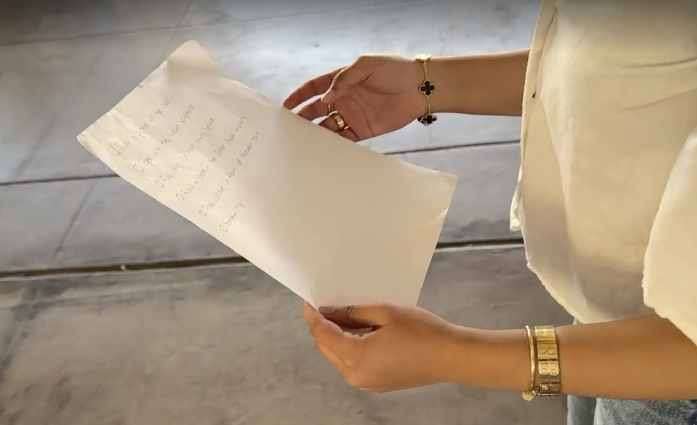

*(Participant Anjali with the bucket list of activities)*

**What Worked:** Both participants completed the whole list! And reported checking off items gave people a sense of accomplishment.

**What Didn’t Work:** Having too many items can be daunting, and inadequate resources can put people off.

**Implications:** People tend to tackle easier tasks first. The assumption was validated so long as the list was manageable.

**Experience Prototype #2**

A platform for fostering deeper connections with your teachers so they can understand who you are and support you with more personalized recommendations, advocacy, and interactions.

**Assumption:** Students are comfortable reaching out to teachers for more than transactional conversations.

**Participants:**

* Britney - a student looking for a coterm rec letter.
* Joan - a high school student who had an underwhelming experience with a teacher.
* Jack - a college freshman vaguely interested in research.

**Recruitment:** snowball recruiting from Experience Prototype #1 (Britney and Jack), Town and Country cold-approach (Joan).

**Task:** Ask each participant to think of a teacher they’d like to have a more in-depth conversation with. Ask them to draft an email to that teacher.

**Post-interview questions:**

* What did writing that email feel like?
* On a scale of 1-10, how comfortable did you feel writing that email?
* Would you feel more comfortable if someone else was making the ask for you?

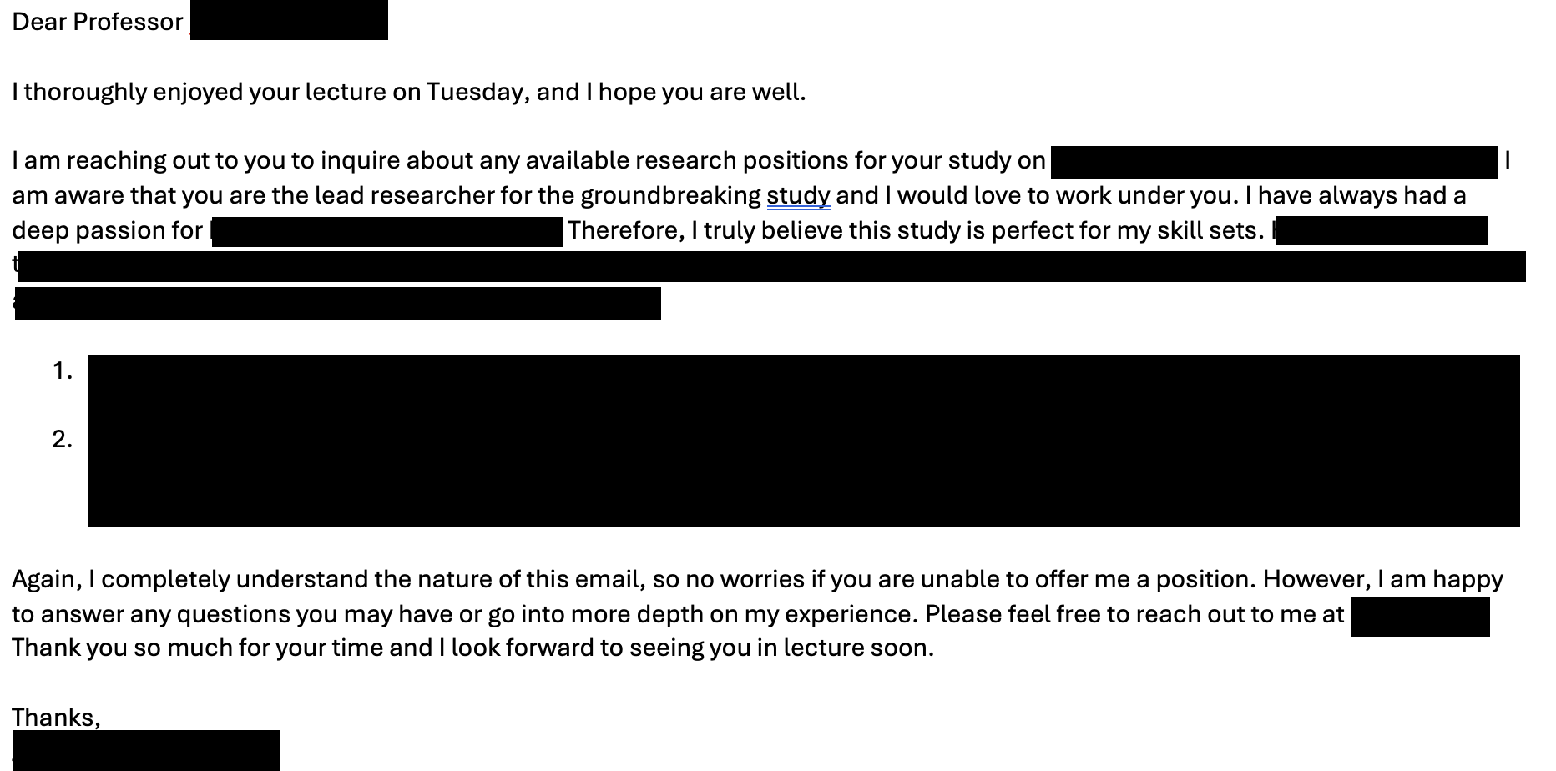

*(Email written by participant Jack)*

**What Worked:** Students were willing to write the email and average comfort was rated as a 6.7/10.

**What Didn’t Work:** Reaching out to previous teachers felt “pointless”, and students were worried about favors they viewed as big asks.

**Insights:** Students like having outside support, but they want to know someone wants to be contacted. Our assumption was somewhat validated.

**Experience Prototype #3**

AI that goes through different students’ handwritten notes and highlights the major factual differences between them.

**Assumption:** Students think it’s worthwhile to cross-reference their notes with others to check for inconsistencies.

**Participant:** Mack, a college freshman who exclusively handwrites notes.

**Recruitment:** snowball recruiting from Experience Prototype #1.

**Task:** Dictate information for the participant to take notes with, knowing they will be quizzed. While they are reviewing their notes, ask them if they’d like to compare with other students’ notes.

**Post-interview questions:**

* Why did you (not) take the notes?
* [If taken] Did the additional notes affect your answers?
* What were you thinking while taking your own notes?

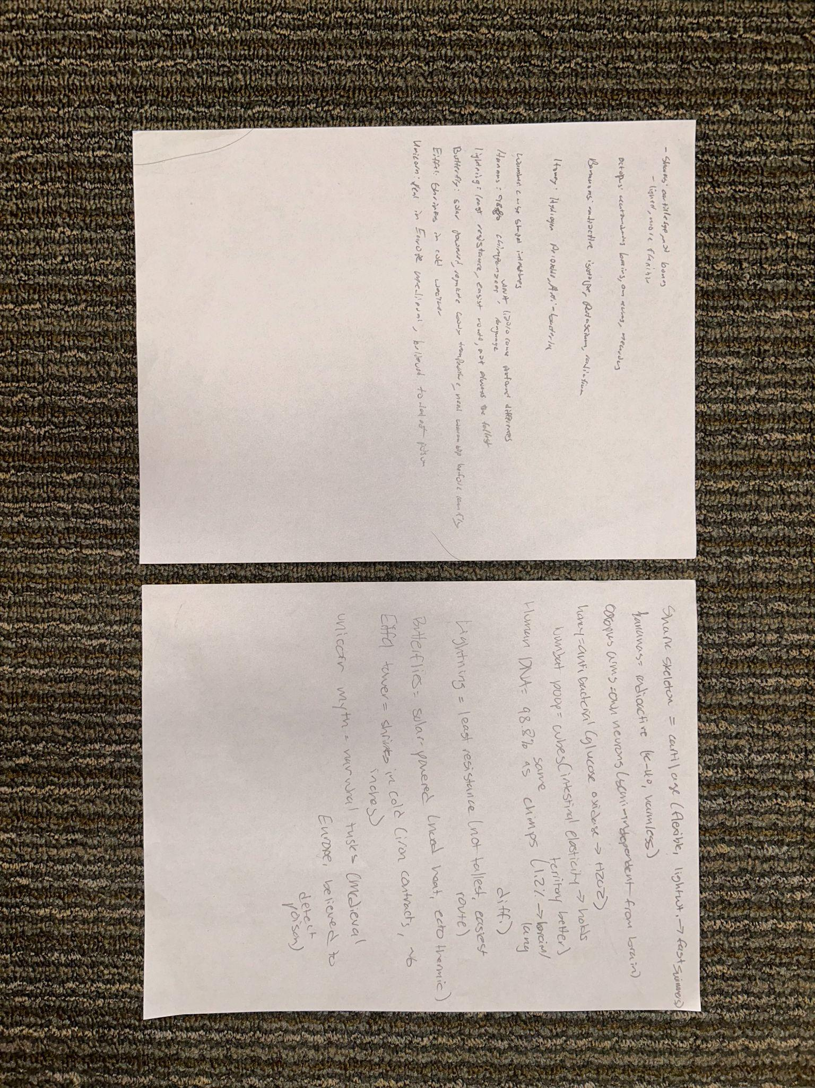

*(The participant Mack’s notes and the notes he was given)*

**What Worked:** Mack took the notes, and the notes helped Mack with information he didn’t write down himself.

**What Didn’t Work:** Mack still missed some answers, and we found that not everyone feels comfortable sharing notes.

**Insights:** Although handwriting is a concern for students, students are willing to accept additional notes and find them useful. Overall, the assumption was validated.

### 

### Design Evolution

#### Final Solution

After conducting our experience prototypes, we decided to move forward with Solution #2: **A platform for fostering deeper connections with your teachers so they can understand who you are and support you with more personalized recommendations, advocacy, and interactions.**

##### Description

Our final solution is a mobile app that enables teachers to post open office hours, inviting students to attend. Students are then shown a list of AI-recommended teachers based on common interests to guide them towards their most compatible mentors. A journaling interface allows users to create private reflections to help them memorialize their interactions.

##### Rationale

After narrowing our demographic to students at large high schools, we learned through the needfinding process that many of the students we interviewed began preparing for their post-high school plans as early as 8th grade. While some students turned to older siblings or upperclassmen for guidance, this left students lacking access to good mentors at a disadvantage.

Although our assumptions were validated in experience prototype #3, we wanted to narrow in on a more impact-driven solution. We primarily focused on experience prototype #2 which highlighted students’ desire to connect with teachers alongside the fear that their requests for connection would be poorly received. To arrive at our final solution, we incorporated the results of experience prototype #1 that demonstrated students receive a sense of accomplishment from completing manageable tasks. Coupled together, the findings from these experience prototypes inspired us to build a platform that encourages meaningful connections between students and teachers while making the process actionable and rewarding.

Additionally, we felt that our selected solution hit at the strongest pain point we found in our needfinding: the disconnect between the support students need and the support teachers can currently provide. Especially in larger schools, where teacher bandwidth is limited and students often feel forgotten in the sea of their classmates, we wanted to help both students and teachers be able to engage and connect more effectively.

#### 

#### Tasks

#### Make a Profile (Simple Task for Teachers and Students)

This simple task is performed by all users. Upon signup, users are guided through the process of providing background information, interests, and a short bio. This is an important aspect of ensuring personalized, high-quality student-teacher AI recommendations, setting the foundation for meaningful connections.

**Student Task Flow**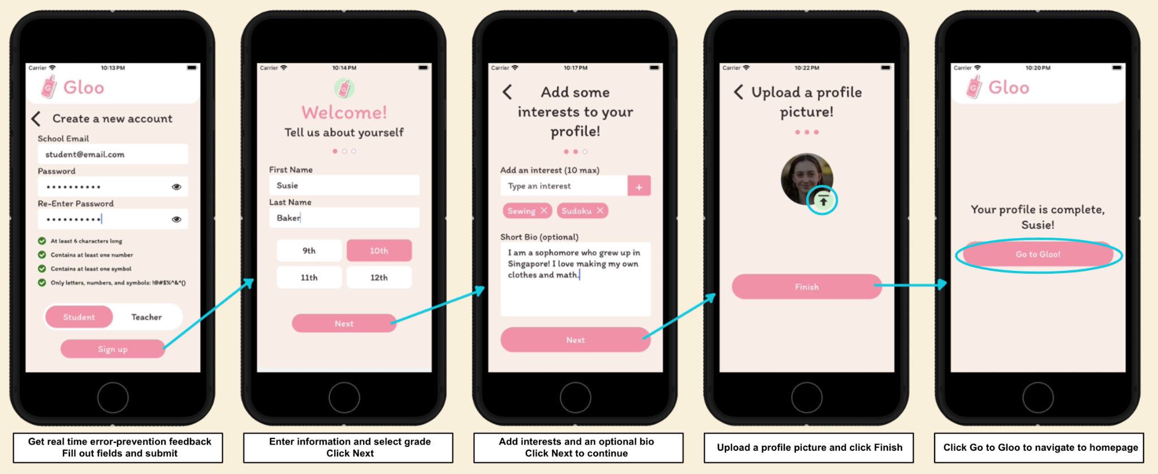

**Teacher Task Flow**

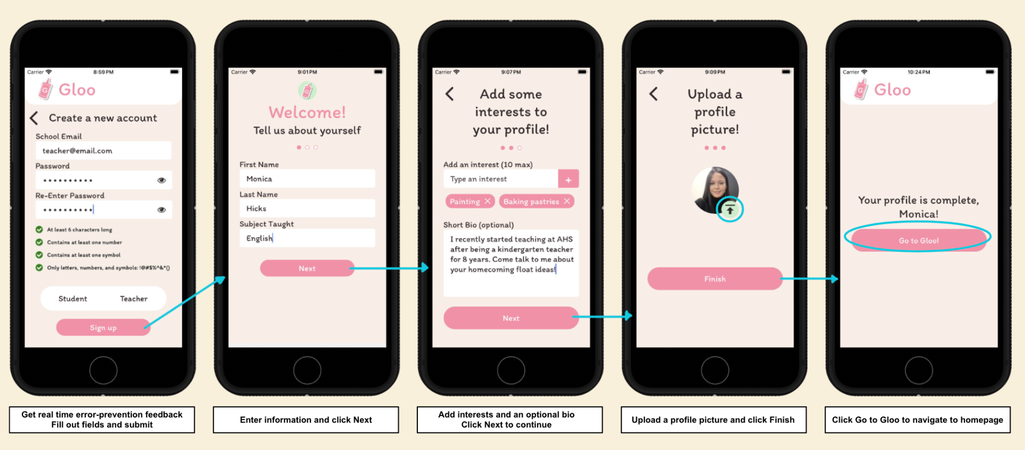

##### Find a Connection (Moderate Task for Students)

This moderate task represents the core functionality of our app for students. By browsing their AI-generated recommendations and signing up to attend office hours, students take an actionable step toward building meaningful relationships. This task is designed to be approachable yet impactful to help students achieve their goal of connecting with the right mentors.

**Student Task Flow**

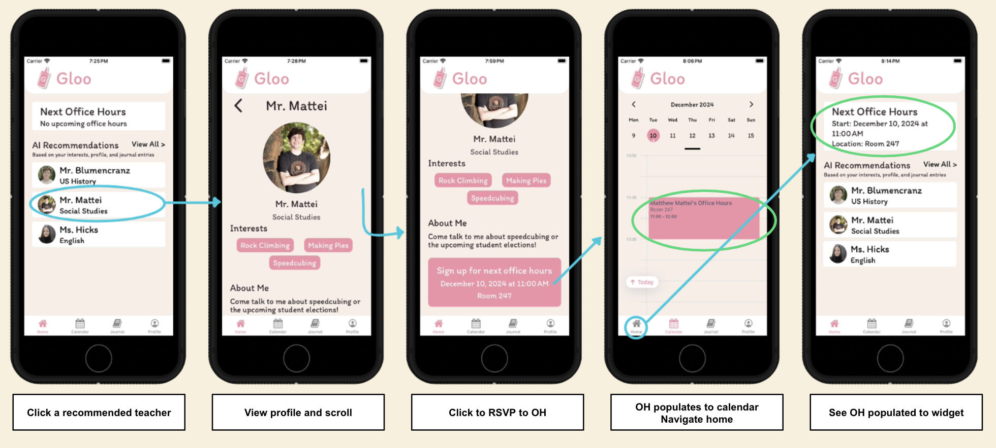

##### 

##### 

##### Create and Share Office Hours (Complex Task for Teachers)

This complex task allows teachers to schedule structured opportunities to connect with their students. Teachers fill in core details such as date, time, and location to communicate their availability to students. Flexible features such as meeting capacity and description allow teachers to personalize their office hours, creating an environment to foster meaningful connections.

**Teacher Task Flow**

##### 

##### 

##### Record Meeting Notes (Moderate Task for Teachers and Students)

This moderate task is optional for teachers and students, giving them flexibility in the level of effort and commitment required. Teacher journal entries are grouped by student, allowing teachers to efficiently access notes on all previous interactions with an individual. Whether it is to write letters of recommendation or prepare for an upcoming meeting, all the student’s details are in one place. Student notes aren’t tied to any specific teacher, allowing them to free-write on their goals and progress over time. These journals are always private, giving users a judgment-free outlet to record what is most meaningful to them.

**Student Task Flow**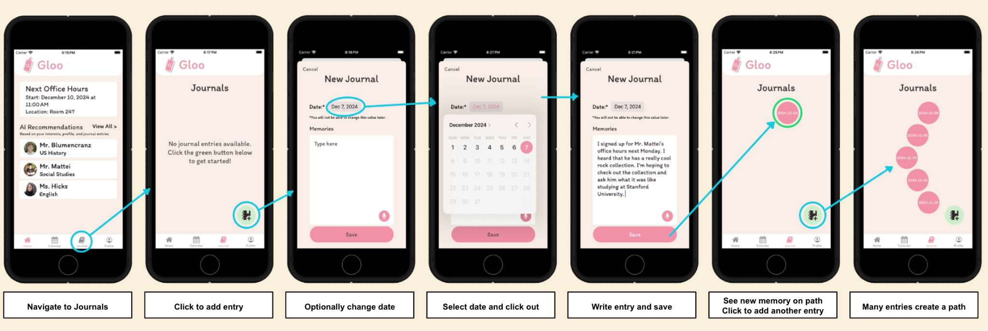

**Teacher Task Flow**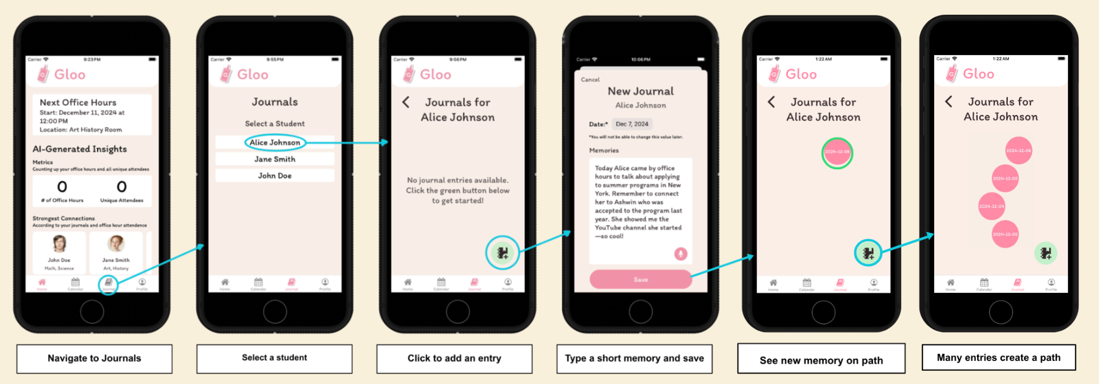

##### 

#### Design Evolution

##### Alternate Realizations

We brainstormed a number of realizations for our app, considering everything from traditional mobile apps to a Samsung fridge application. We strongly considered building a smartwatch app to deliver our solution. Some of the benefits of a wearable app would be the ease of receiving push notifications for users and the more common acceptance of having a watch in class than having a mobile phone in class. However, we couldn’t get past the major drawback of small, inaccessible screens and the barrier to adoption for students without access to a smartwatch.

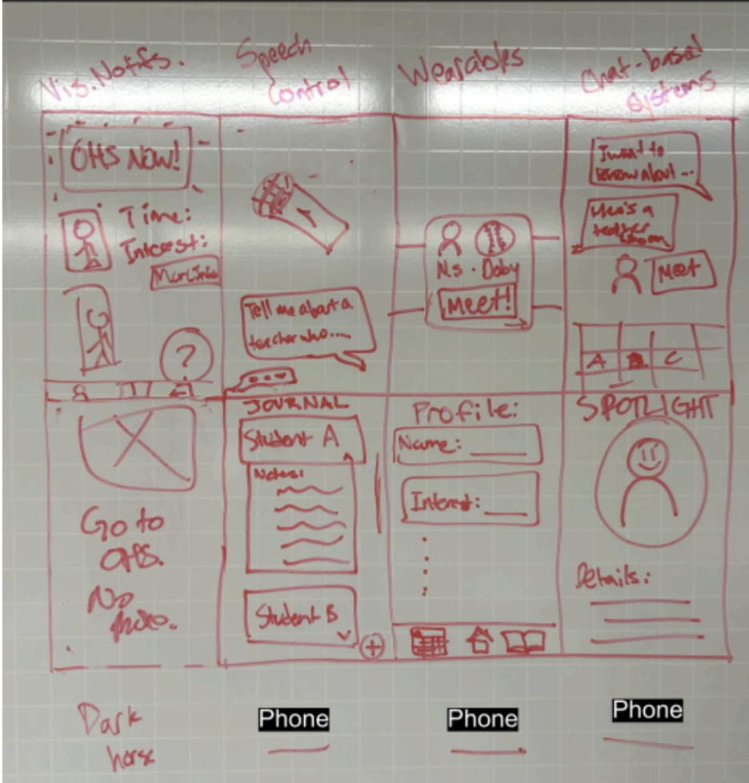 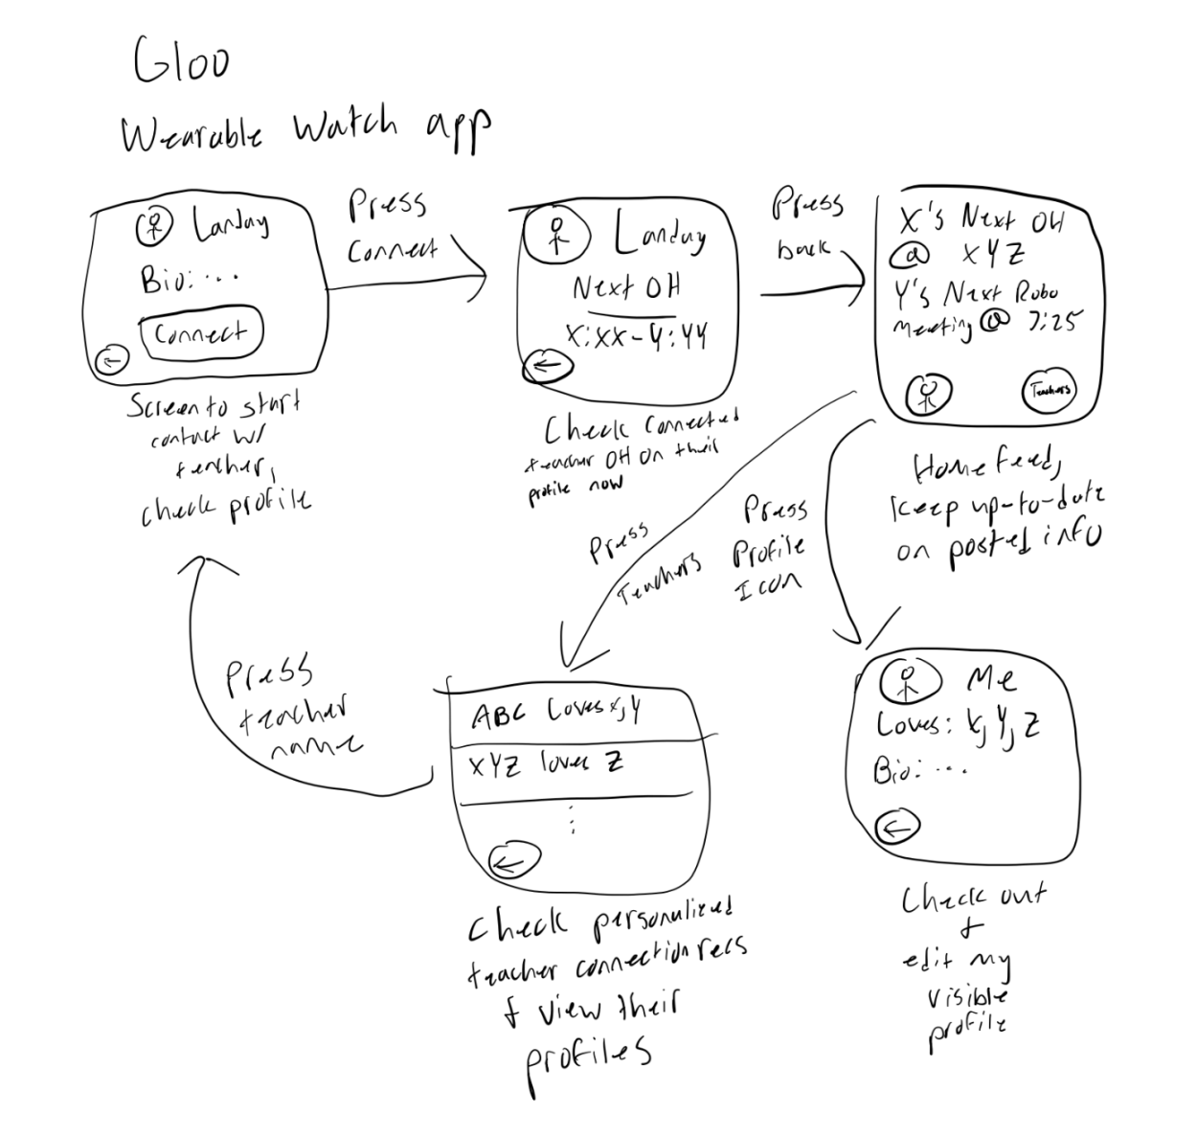

*Variety of realizations considered (left) and smartwatch realizations(right)*

We settled on creating a mobile application, prioritizing the ubiquitousness of smartphones amongst high school students (95% of high school students have access to a smartphone, compared to just 13% with a smartwatch) and the capacity smartphones have to introduce complexity despite potential drawbacks such as encouraging screen time for high school students.

#### 

##### Lo-Fi Sketches

We began sketching out our app realization for a mobile platform. We drew our lo-fi prototype in Notability, ensuring we maintained consistent aspect ratios for screens and navigation options. This allowed us to focus explicitly on the usability of the design during lo-fi prototype testing. A couple are shown below, and the rest are in the appendix.

**Find a Connection (Moderate Task for Students)**

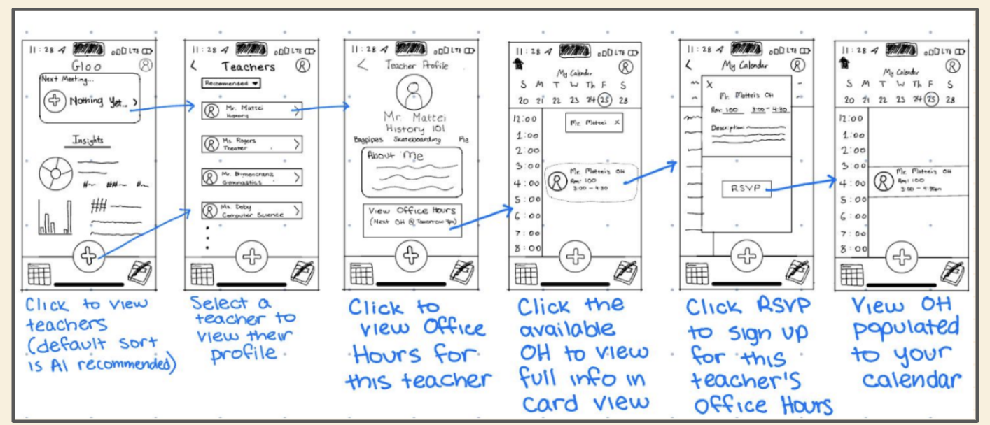

**Record Meeting Notes (Moderate Task for Students)**

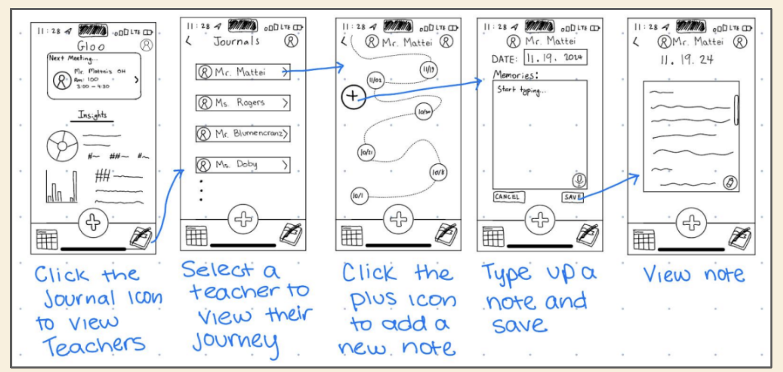

We originally wanted the student journaling interface to operate like the teachers’ version, connecting memories to specific teachers. We have since made journaling a more personalized experience for students, giving them the flexibility to journal daily by not tying journals to a specific teacher.

##### Lo-Fi Prototype Testing

**Evaluation Technique**

Our lo-fi prototype testers included students we cold-approached in Town & Country, a Stanford professor, and a remote high school student found through personal network connections. We had one team member act as the facilitator, one as the note taker/recorder, and one as the computer. For remote interviewees, we sent a link to our Lo-Fi prototype in Marvel.

##### 

*In-person student testing (left), in-person teacher testing (middle), remote student testing (right)*

**Implications**

We found that students had a much higher rate of misclicks, typically clicking through multiple pages to find what they were looking for. Despite this, students completed tasks nearly twice as quickly as teachers. We primarily attribute this difference to the way different generations interact with technology; the younger generations are more likely to navigate quickly, unafraid to make mistakes and have to backtrack.

**Design Response**

Our major takeaway from this was that navigation icons needed to be descriptive. Between our lo-fi and med-fi prototypes, we removed the ambiguous plus button from the bottom nav bar and replaced it with descriptive icons to be more representative of their functionality. We also received feedback that switching between a back button and a home button in the top left was unintuitive for users, so we moved the home button to the bottom navigation bar.

##### Med-Fi Prototype

For our med-fi prototype, we incorporated the changes above and introduced color to help better guide the user through the task flows. Our med-fi prototype was tested by other studio members over the course of several days, giving them ample time to explore the application’s features. After their testing, we were given a full heuristic evaluation, which is detailed in the next section.

A couple of the screens are shown here, and the rest can be found in the appendix.

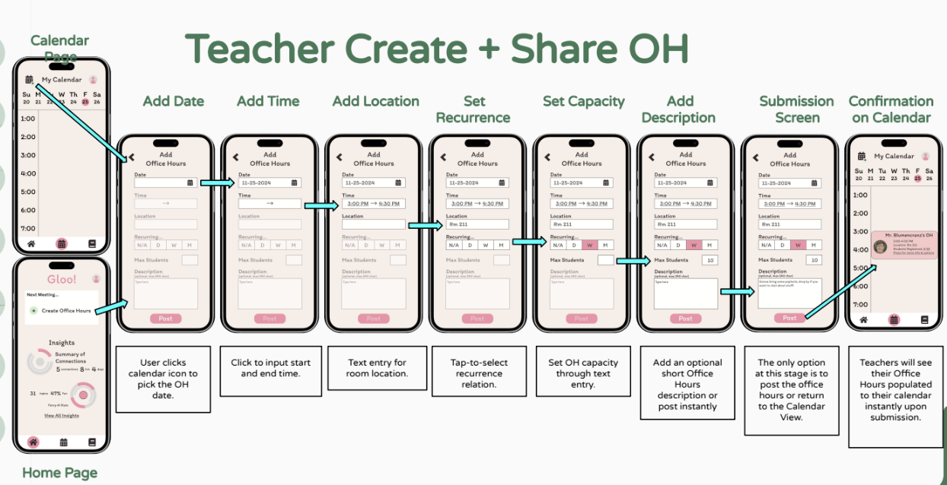

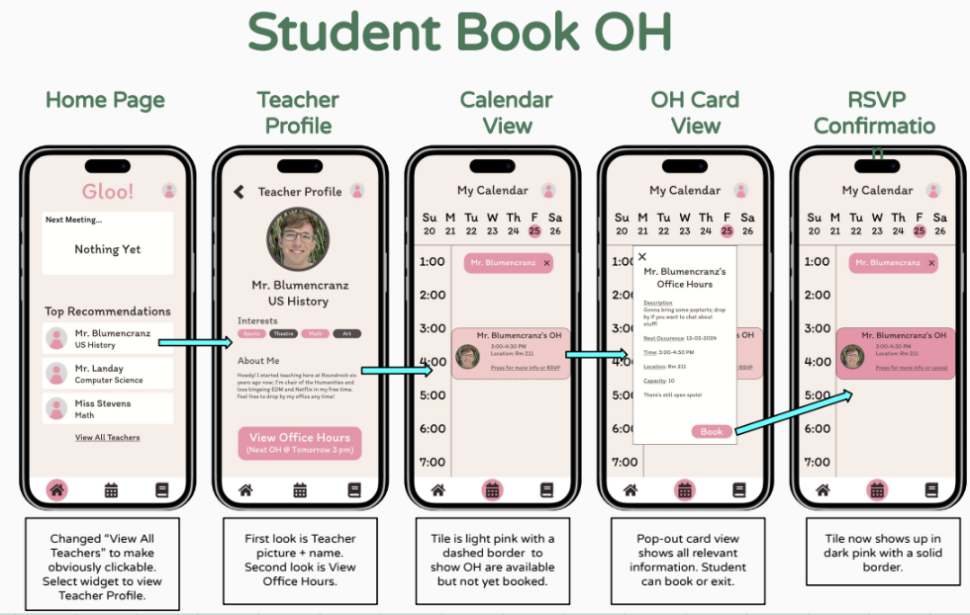

##### Results of Heuristic Evaluation

Our classmates conducted a heuristic evaluation of our medium-fidelity prototype, presenting us with a total of 65 violations. The majority of these violations were severity 2 and related to user control/freedom and visibility of system status.

##### 

Below, we have detailed the rationale behind the revisions we chose to incorporate, as well as the rationale behind some of the higher-severity revisions we did not choose to incorporate.

**Incorporated Severity 3 and 4 Feedback Revisions**

Provide error warnings when abandoning tasks (H9 - Severity 4)

We think this is a great way to incorporate error prevention in our app. We created custom GlooAlerts to prevent errors in our final hi-fi prototype.

Avoid abbreviations (“D” for day, “OH” for Office Hours”) (H6, H2 - Severity 4,3)

This helps improve our app’s accessibility and navigability. We transitioned from niche abbreviations to spelling everything out in full terms in our hi-fi.

Provide higher contrast between tentative and registered OH (H5 - Severity 4)

This is an important accessibility concern. We incorporated this feedback by only allowing students to RSVP for the very next upcoming office hours. It will only populate to their calendar and homepage if they have RSVPed.

Display current student name when drafting journal entry (H1 - Severity 3)

This promotes recognition over recall and provides affordances if a teacher is interrupted in the middle of entering memories about a student. Each journal entry page in our hi-fi contains the current student's name at the top of the page.

Include formatting and AM/PM for calendar times (H5 - Severity 3)

This is an important aspect of preventing in-real-life errors, such as a teacher or attendees missing office hours due to confusion. We incorporated this feedback by adding a time picker to the Create OH screen.

Provide alternate content viewing for the calendar (H7 - Severity 3)

We incorporated this functionality so users could see their upcoming schedule at a glance. Users can swipe between week and month views from the top calendar nav bar.

Tooltip for password (H10 - Severity 3)

We had this in our med-fi, but it was not yet functional. We happily incorporated this feedback into our hi-fi to prevent errors and guide users through the signup process.

Provide onboarding popups (H10 - Severity 3)

We think this is an important aspect of orienting the user in the app and helping them understand the functionality and intended impact. We want users to understand how and why we use AI, and we want them to journal with confidence this information is private.

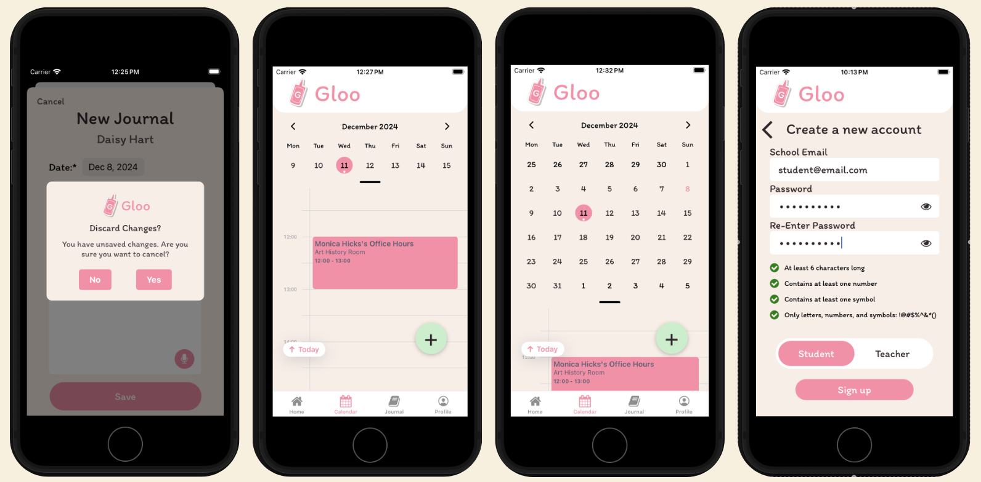

*From left to right: Abandonment notifications and including the student’s name on the journal entry page, only populating RSVPed office hours, alternate week/month view, tooltip guidance for password creation.*

**Other Incorporated Feedback**

Onboarding Popups for Homepage

Teachers receive custom messages about creating office hours and viewing journaling recommendations for students. Students receive custom messages on teacher recommendations and how to attend office hours.

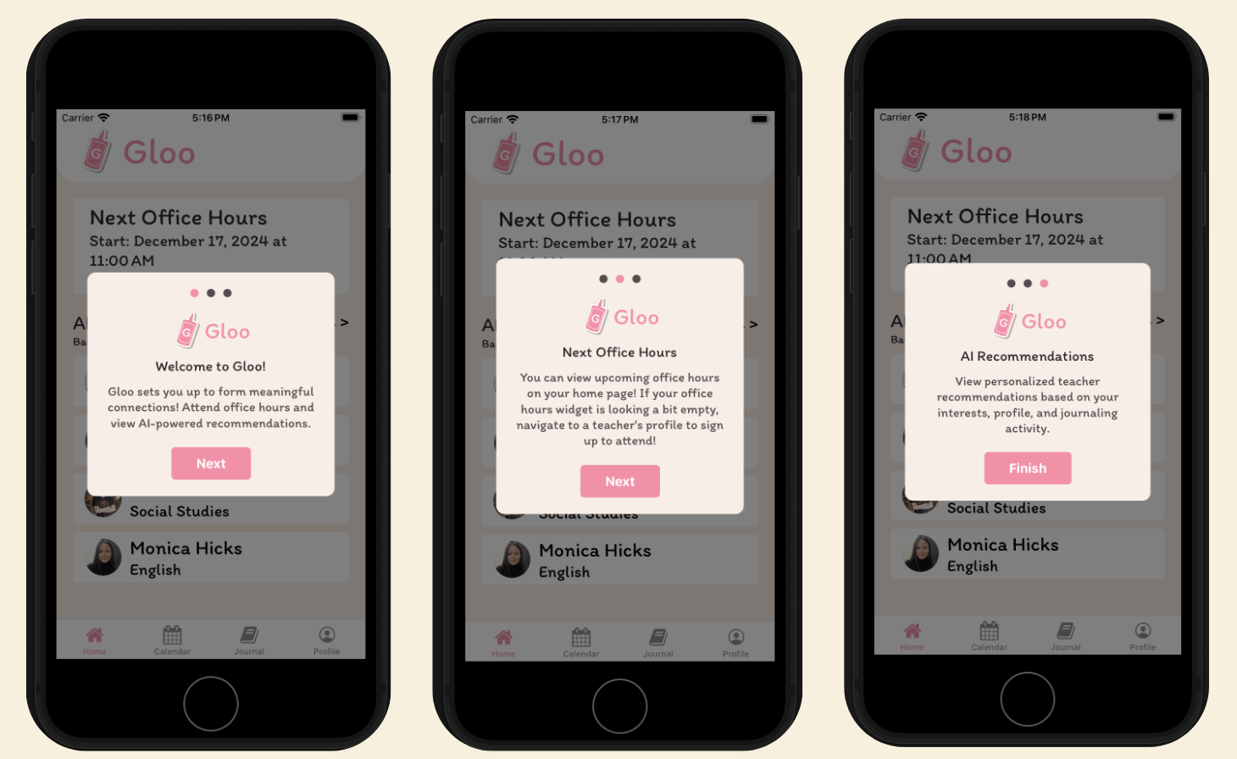

Onboarding Popups for Journals

Journaling popups are also personalized for teachers and students, highlighting the way our design choices target meaningful connection.

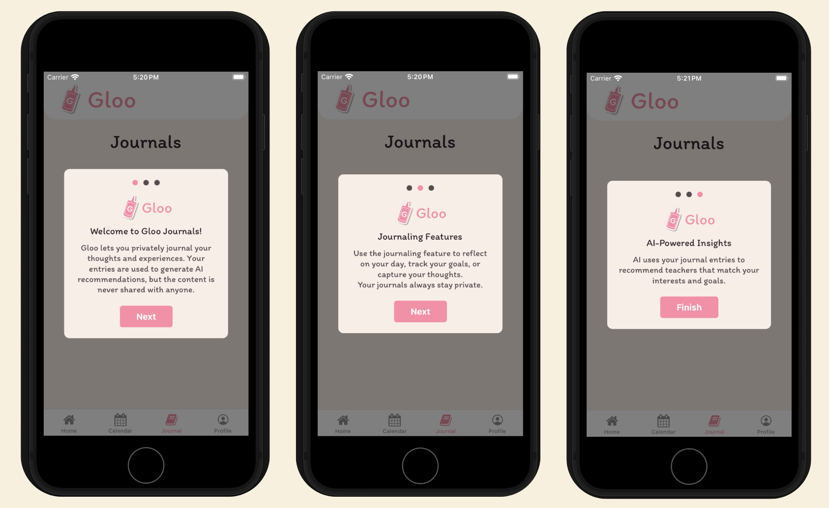

**Unincorporated Revisions**

Posting every available OH greyed out on the calendar (H1 - Severity 3)

We decided against incorporating this feedback since our demographic is large high schools. We believe this would lead to severe overcrowding of the calendar.

Swipe to delete journal entries (H3 - Severity 3)

When presenting this revision for peer feedback in CS 147 studio, it was brought to our attention that swipe-to-delete may increase the error rate for our users. To avoid this, we incorporated a delete button on each journal entry instead, complete with a confirmation alert to further reduce errors.

Hiding your own OH + undo-delete Office Hours (H1, H5 - Severity 3)

The functionality to undo-delete events is not standard for any industry calendar, so we decided against incorporating it.

Change “Recent” to “Recent Journal Entries” (H1 - Severity 3)

Since the Journal page is already clearly listed, we decided against incorporating this feedback in order to uphold an esthetic minimalistic design.

#### 

#### Values in design

##### Core Design Values

When considering design choices, revisions, and app structure, we kept our core values at the forefront of our minds. Below are some of the values we emphasized the most.

**Navigable**

To have a usable application, navigability is crucial. We always want our users to know exactly which steps to take to accomplish a task. We encoded this value in our design by integrating icons that clearly label their functionality. Users can navigate to their homepage, calendar, journal page, or profile from any screen using the well-labeled navigation buttons in the footer. We give easy exit strategies throughout the app, letting users cancel, go back a page, or exit from any task. To highlight floating buttons, we used bright colors to grab the user’s attention. When you use Gloo, navigation is easy.

**Safe**

Because we work with a sensitive population, ensuring privacy and safety are crucial. You can see this incorporated throughout our design from requiring profile pictures to ensuring the privacy of journals. We also made the decision not to allow communication between students, focusing purely on finding teacher mentors.

**Accessible**

Another core value of Gloo is accessibility. We incorporated this value into our design by offering a range of input methods such as a scroll date and time picker in our calendar and large easy-to-click icons.

**Transparent**

We know that AI is new and can be intimidating to some inexperienced users. To combat this aversion, Gloo incorporates its core value of Transparency throughout our design. We clearly label places where AI is incorporated and give users a brief description of the data used for these features and exactly how it helps them achieve their goals of building meaningful connections.

##### Tensions in Value Design

We had a potential tension arise where teachers might want to reach out to specific students, but we made the design choice to have all connections be student-initiated. This was motivated by our market research process where we learned a would-be competitor, Edmodo, went out of business after the FTC sued them for violation of the Child Online Privacy Protection Act. At Gloo, safety is paramount.

Another potential tension we noticed was using pink and green throughout our design. We know that red and green can be tricky for some users, so we wanted to be careful. One of our teammates experiences color vision deficiency, and we used their lived experience to make sure all of our color schemes were accessible to this population. Because our primary background color is a minimalistic beige, we found that users can still identify and interact with these buttons without issue.

##### 

### Final prototype implementation

#### Tools used

We coded our app in **React Native**, which has the benefit of being easy to learn and enables cross-platform development. One drawback of using React Native is that React Native frequently re-renders on changes, which leads to lagging for complex functions.

For simulation testing, we used **Expo**. Expo allowed us to easily interact with our codebase by seeing the changes updated in real-time as we edited and saved our code. One drawback of using Expo is dealing with finicky errors, such as the app reloading whenever we type a string with the character ‘r’ in it (the simulator registers ‘r’ as a *reload* command.

To collaborate, we used **GitHub**. GitHub was a great way to work on the codebase simultaneously while ensuring we could revert to a previous version. The biggest challenge with Github was not knowing when someone else had pushed their code to the remote repository; we often worked on overlapping files, leading to merge conflicts.

To store our data, we used a free version of **Supabase**. Supabase was a great way to bring our app to life, allowing us to input real data that persisted between sessions. One drawback of using a free Supabase account was that it is presumably less robust than a paid-for database. This resulted in spurious network failures, which led to failed fetches and malformed entries in the database. This required bloating our codebase with heavy error handling to protect virtually every database function against null values.

#### 

#### 

#### Hard-coded Techniques

As Gloo is an inherently social app that requires many users, some aspects of our app have been hard-coded. Our app doesn’t allow teachers to list office hours in the past, and students can’t RSVP to office hours that have already happened. For this reason, we hardcoded some “previously occurring” office hours, manually adding students as attendees so that students show up as recent interactions for the teachers.

#### Wizard of Oz Techniques

To mimic AI-powered recommendations, we implemented Wizard of Oz techniques to make it appear as though teachers show up as personalized “AI Recommendations” to the students. The students that show up as a teacher’s AI-generated “Strongest Connections” are represented through similar Wizard of Oz mocking.

### Reflection and Next Steps

#### Main Takeaways

Our main takeaway from developing this solution has been that everything is a tradeoff. It is nearly impossible to please every user, and under the crunch of limited time and resources, certain initiatives had to be prioritized. We learned that building an app that effectively addresses a pain point had different outcomes than we anticipated. In some aspects, such as gaining access to interview participants and industry experts, we found it much easier than planned. On the other hand, narrowing in on the “best” solutions and actually building the final product were much heavier lifts than expected. We are all extremely grateful for having the opportunity to learn and grow in this fast-paced course.

Our studio’s theme was *AI in the Classroom*, a welcome challenge to design a solution for use within the physical classroom space. We’ve found that keeping the needs and desires of both students and teachers in equal consideration is a difficult balance; maintaining that balance was essential to the success of our app. We agree that the design thinking process we completed this quarter, while not guaranteed to produce valid and effective solutions, is worth the significant time and effort in the name of thoughtful, rational, and ethical design.

#### Next Steps

The next steps for our app would be to refine our design and incorporate more of our heuristic feedback. If we were to pursue this app in earnest, we would need to look into a premium database management system with fewer network failures. After addressing these challenges, it would be time to get Gloo out into the world. We believe in this app, and we think it does a phenomenal job of addressing a real gap in US high schools.

### 

### Appendix

Lo-Fi Sketches Continued

**Record Meeting Notes (Moderate Task for Teachers)**

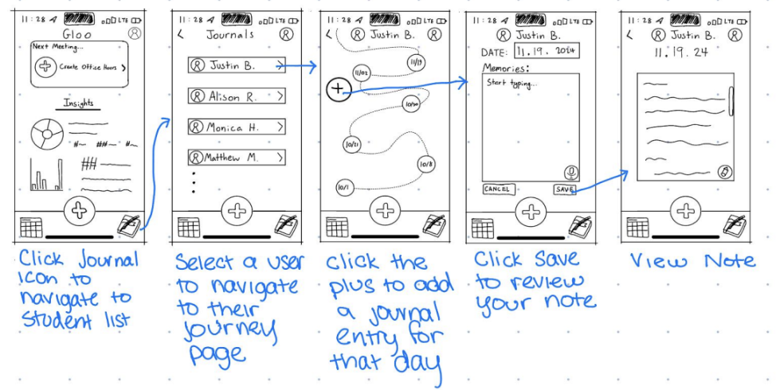

**Create and Share Office Hours (Complex Task for Teachers)**

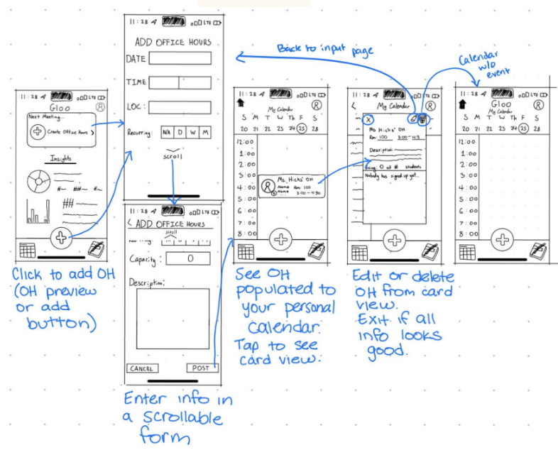

Med-Fi Sketched Continued

